# **TESTING KAFKA**

This is a short document including the basic commands to check if Kafka is working as expected. It includes creating a topic, producing to the topic and consuming from the topic.

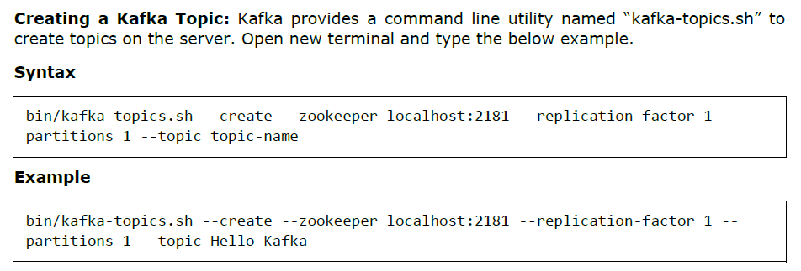

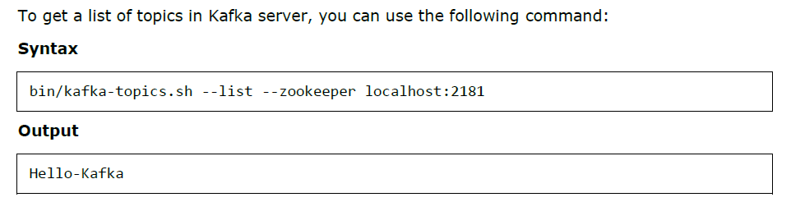

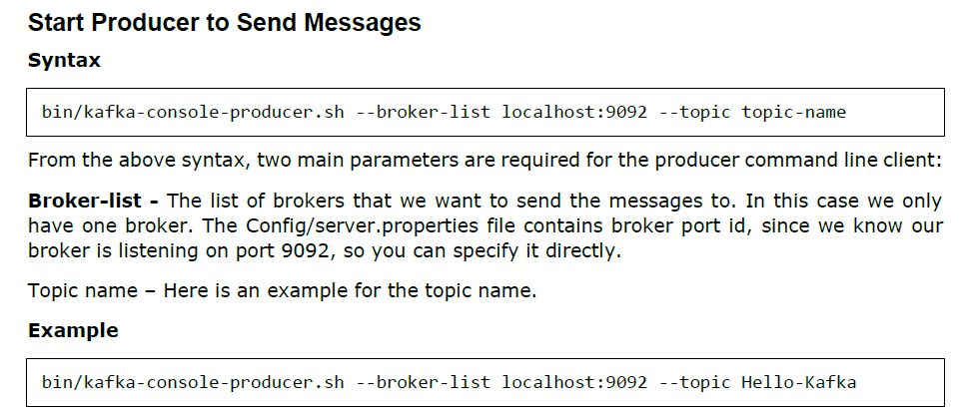

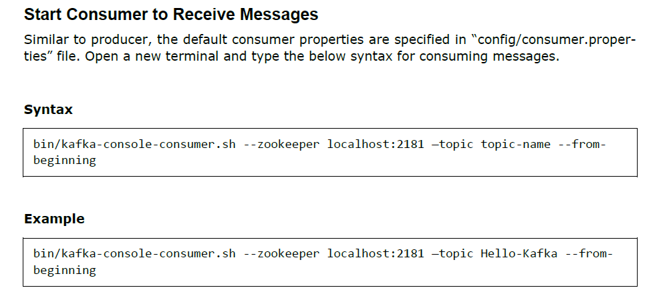

For a more detailed tutorial plus program examples, refer **apache_kafka_tutorial.pdf** in the **References** folder of the repository.